The nervous system
The nervous system comprises the central nervous system, consisting of the brain and spinal cord, and the peripheral nervous system, consisting of the cranial and spinal nerves.
- Central nervous system
- Brain
The brain is the enlarged, head end of the central nervous system; it occupies the cranium, or brain case.

The brain presents four main divisions:
1.1. Brain stem: medulla, pons & midbrain
1.2. Diencephalon: thalamus & hypothalamus
1.3. Cerebellem
1.4. Cerebrum

- Spinal cord
The spinal cord is a long, cylindrical mass of nervous tissue, oval or rounded in transverse section. It protected by the bony structure of the vertebral column. It occupies the upper two thirds of the vertebral canal.

- Peripheral nervous system
- Cranial nerves: 12 pair attached to undersurface of brain.
- Spinal nerves: 31 pair attached to spinal cord.

Spinal nerves are classified into:
  - Somatic nervous system (voluntary)
• Relays information from skin, sense organs & skeletal muscles to CNS
• Brings responses back to skeletal muscles for voluntary responses

  - Autonomic nervous system (involuntary)
• Regulates bodies involuntary responses
• Relays information to internal organs

Autonomic nervous system is divided into:
    - Sympathetic nervous system: in times of stress, emergency response and fight or flight
    - Parasympathetic nervous system: when body is at rest and digestion or normal everyday functions

Meninges
The brain and spinal cord are surrounded and protected by layers of non-nervous tissue, collectively termed meninges. These layers, from without inward, are the dura mater, arachnoid, and pia mater. The space between the arachnoid and the pia mater, the subarachnoid space, contains cerebrospinal fluid (CSF).

Cellular structure of the nervous system
- Neuron
Parts of a neuron:
• Dendrite: receive stimulus and carries it impulses toward the cell body
• Cell Body: with nucleus and most of cytoplasm
• Axon: fiber which carries impulses away from cell body
• Schwann Cells: cells which produce myelin or fat layer in the peripheral nervous system
• Myelin sheath: dense lipid layer which insulates the axon and makes the axon look gray
• Node of Ranvier: gaps or nodes in the myelin sheath

Three types of Neurons:
- Sensory neurons: bring messages to CNS
- Motor neurons: carry messages from CNS
- Interneurons: between sensory & motor neurons in the CNS

Synapse
The synapse or “gap” is the place where information is transmitted from one neuron to another. Synapses usually form between axon terminals and dendritic spines, but this is not universally true. There are also axon-to-axon, dendrite-to-dendrite, and axon-to-cell body synapses. The neuron transmitting the signal is called the presynaptic neuron, and the neuron receiving the signal is called the postsynaptic neuron (Note that these designations are relative to a particular synapse). Most neurons are both presynaptic and postsynaptic.
Types of synapses:
- Chemical synapse: When an action potential reaches the axon terminal it depolarizes the membrane and opens voltage-gated Na⁺ channels. Na⁺ ions enter the cell, further depolarizing the presynaptic membrane. This depolarization causes voltage-gated Ca²⁺ channels to open. Calcium ions entering the cell initiate a signaling cascade that causes synaptic vesicles, containing neurotransmitter molecules to fuse with the presynaptic membrane. Fusion of a vesicle with the presynaptic membrane causes neurotransmitter to be released into the synaptic cleft, the extracellular space between the presynaptic and postsynaptic membranes. The neurotransmitter diffuses across the synaptic cleft and binds to receptor proteins on the postsynaptic membrane.
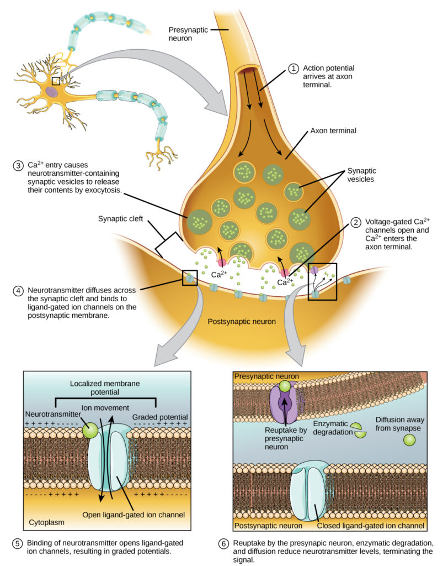

- Electrical Synapse
While electrical synapses are fewer in number than chemical synapses, they are found in all nervous systems and play important and unique roles. The mode of neurotransmission in electrical synapses is quite different from that in chemical synapses. In an electrical synapse, the presynaptic and postsynaptic membranes are very close together and are actually physically connected by channel proteins forming gap junctions. Gap junctions allow current to pass directly from one cell to the next. In addition to the ions that carry this current, other molecules, such as ATP, can diffuse through the large gap junction pores.
There are key differences between chemical and electrical synapses. Because chemical synapses depend on the release of neurotransmitter molecules from synaptic vesicles to pass on their signal, there is an approximately one millisecond delay between when the axon potential reaches the presynaptic terminal and when the neurotransmitter leads to opening of postsynaptic ion channels. Additionally, this signaling is unidirectional. Signaling in electrical synapses, in contrast, is virtually instantaneous (which is important for synapses involved in key reflexes), and some electrical synapses are bidirectional.
Action Potential
A cell's membrane potential is caused by different electrical charges on the inside and outside regions of the membrane. At rest, the cell membrane is more negative on the inside and more positive on the outside. A membrane potential is a form of potential energy. A change in the membrane potential can cause an electrical signal in excitable tissue. The action potential is a large change in the membrane potential of a neuron from a resting value of about -70 mV to a peak of about +30 mV and back to -70 mV. The action potential is generated at the axon hillock, where there are many voltage gated sodium channels.
The steps:
a. It begins when signals from the dendrites and cell body reach the axon hillock and cause the membrane potential there to become more positive (depolarization).
b. As the axon hillock depolarizes, voltage-gated channels for Sodium open rapidly. Sodium moves down its concentration gradient into the cell. The membrane potential becomes more positive as Sodium moves into the cell.
c. If the stimulus to the axon hillock is great enough, the neuron depolarizes enough to reach a trigger point called threshold, which is -55 mV. At threshold, depolarization opens more voltage gated sodium channels, which causes sodium to flow into the cell, which causes the cell to depolarize further, opening still more voltage gated sodium channels. A wave of depolarization spreads from area to area of the cell, moving down the axon, depolarizing the area as it goes along. This wave is the nerve impulse.
d. Once the action potential has traveled down the axon, the sodium gates close and the voltage gated potassium channels open, causing potassium to move out of the membrane, following it's concentration gradient. This causes the membrane to repolarize, that is become more negative on the inside compared to the outside. This interrupts the positive feedback loop and ends the rising action potential.
e. In some neurons, the voltage gated potassium channels remain open after the cell has repolarized. Potassium continues to move out of the cell, causing the membrane potential to become more negative than the resting membrane potential (hyperpolarization) Once all the potassium channels are closed, hyperpolarization ends.

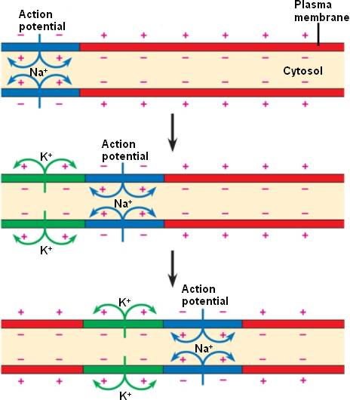

- Neuroglia: also called glial cells or glia, are non-neuronal cells in the central nervous system and the peripheral nervous system.

Types of Neuroglia: Neuroglia are categorized into six subtypes.
- Four of them are present in the CNS:
- Astrocyte
- Oligodendrocyte
- Microglia
- Ependymal cell
- Two of them are present in the PNS:
- Satellite cell
- Schwann cell
  - Neuroglia in the Central Nervous System:
- Astrocytes: They provide protection and support to neurons, exchanging nutrients and other important chemicals.
Astro is the Greek root word for “star.” They have many cell extensions called processes, used for chemical exchanges, that branch out like the points of stars.
These processes connect with neurons, other types of tissue such as blood vessels in the brain or spine, or importantly, the blood brain barrier. The blood brain barrier is a protective membrane surrounding the spine and brain.
The blood brain barrier allows small molecules such as respiratory gases to pass through, while blocking anything larger. Medical and pharmaceutical researchers making drugs that need to reach the brain have to ensure that they have a way for their medicine to cross the blood brain barrier.
- Oligodendrocytes: wrap around the axons of CNS neurons to provide electrical insulation called myelin sheaths. This allows the signal to move quickly enough for proper functioning. In many neurodegenerative diseases, the myelin sheaths are damaged.

- Microglia: Like macrophages in the blood, they surround and digest damaged or invading cells. They are considered the immune cells of the CNS.

- Ependymal cells: line the empty cavities called ventricles in the brain and have access to nearby blood vessels. They filter some of the materials out of the vessels to manufacture CSF.

  - Neuroglia in the Peripheral Nervous System:
- Satellite cells: function to provide nutrients and protection to neurons in the PNS.
- Schwann cells: wrap themselves around the axons of neurons in the PNS. The axon is the long, thin part of the neuron, along which the electrical signal passes. The Schwann cell forms a protective layer called the myelin sheath – this operates like the insulated coating on electrical wiring. Without it, the electrical signal can be disrupted, slowed or stopped altogether.

References
Bossy, J., Atlas du systeme nerveux, Editions Offiduc, Paris, 1971.
De Armond, S. J., Fusco, M. M., and Dewey, M. M., Structure of the Human Brain, 2nd ed., Oxford University Press, New York, 1976.
Gardner, E., Fundamentals of Neurology, 6th ed., W. B. Saunders Company, Philadelphia, 1975.

